**Back-office manual**



**Table of contents**

Introduction 3

Basic principles and components used in eWitness 3

Setting up the system 4

Step 1: Label design 4

Step 2: Print definition 5

Step 3: Define witness points 7

User management 10

Report definitions 11

Putting it all together 12

Using the system to plan a witness cycle 12

Finding or creating patients 12

Linking patients together as a couple 14

Creating a witness cycle for a couple 15

Overview of witness cycles in the lab view 16

Tablet and desktop view 18

View and register misscans 19

# Introduction

To use eWitness, there are a number of set-up and configuration settings to manage. This manual is intended for eWitness as a stand-alone system. To use eWitness together with eBase, there is a separate set-up manual.

# Basic principles and components used in eWitness

To set up eWitness, there are a number of elements that need to be configured. There are three main steps involved, each with a corresponding set-up menu. The first is the label design. This menu is used to configure labels and calculate the labels to be generated. The second step is the definition of print-outs. Labels are printed with a separate app, which is installed on the dedicated barcode scanners that are part of the eWitness solution. The third step is the definition of witness points. In this step, the workflow is defined.

Furthermore, there are menus for the user settings as well as the report settings. All of these settings will be explained in the following chapters. The “Settings” menu can be found on the left side of the main eWitness screen (fig. 1).

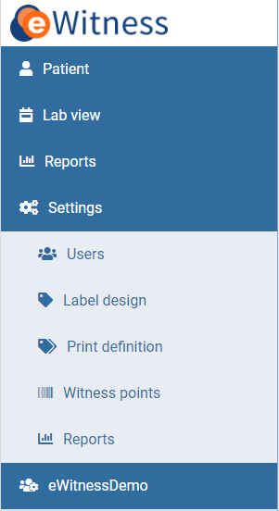

Figure 1: Settings menu

# Setting up the system

## Step 1: Label design

A label is a small report that combines the native printer language with the patient identification data. By default, labels are configured by eFertility during installation. A label definition can be changed or added by the local administrator. The printer language used to send the labels to the printer can be complicated to create from scratch, but easy to alter. A report to produce a label design has the type “eWitness” and consists of a header and a body. The header is used to define the label, the body to add the database fields to the layout. If needed, eFertility can provide assistance for managing the label. Basically, all the data available in eWitness can be used for the label design.

In the “Settings” menu, click on “Label design”. This will give you an overview of your labels (fig. 2). On this page, you can edit existing labels or define new ones. Double-click on a label to open it or click the “+new” button to create a new one.

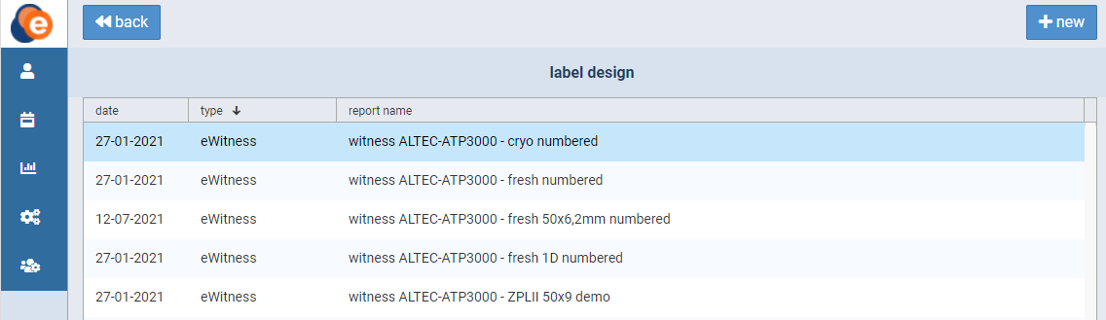

Figure 2: Label design overview

Once a label has been opened or created, a new screen will appear (fig. 3). Here, you can edit the label settings. The screen consists of two sections: template and query. Use the template section to configure the type, name, date and group of the label as well as the state (active/inactive). The date, name and type will be displayed on the overview page. The report group will be used to group labels in the “Reports” functionality.

In the query section, the actual code can be edited. If you don’t feel comfortable doing this yourself, feel free to contact eFertility for assistance. Once you’re finished, click the “save” button to save.

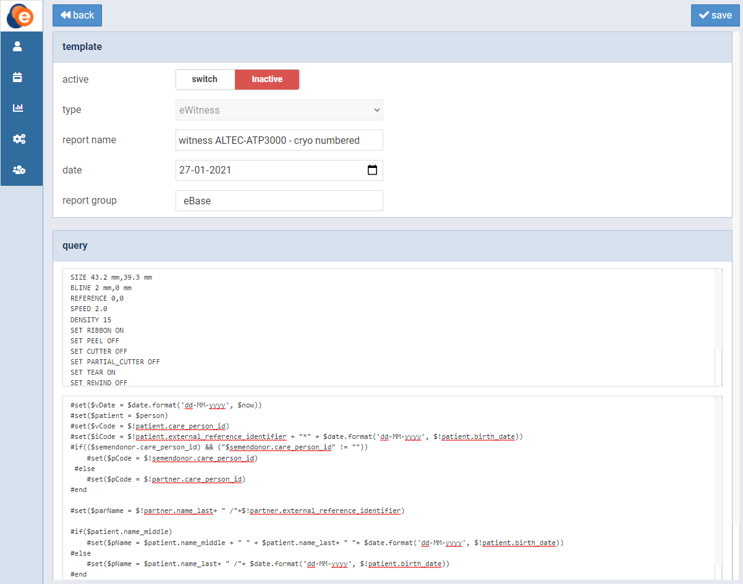Figure 3: Editing a label

## Step 2: Print definition

In a print definition, you configure the “when, what and how many” of the labels. You can group different print definitions together in a menu or keep them separate. This can be configured to reflect the internal process in the clinic.

In the “Settings” menu, click on “Print definition”. This will give you an overview of your print-out definitions (fig. 4). On this page, you can edit existing definitions or define new ones. Double-click on a definition to open it or click the “+new” button to create a new one.

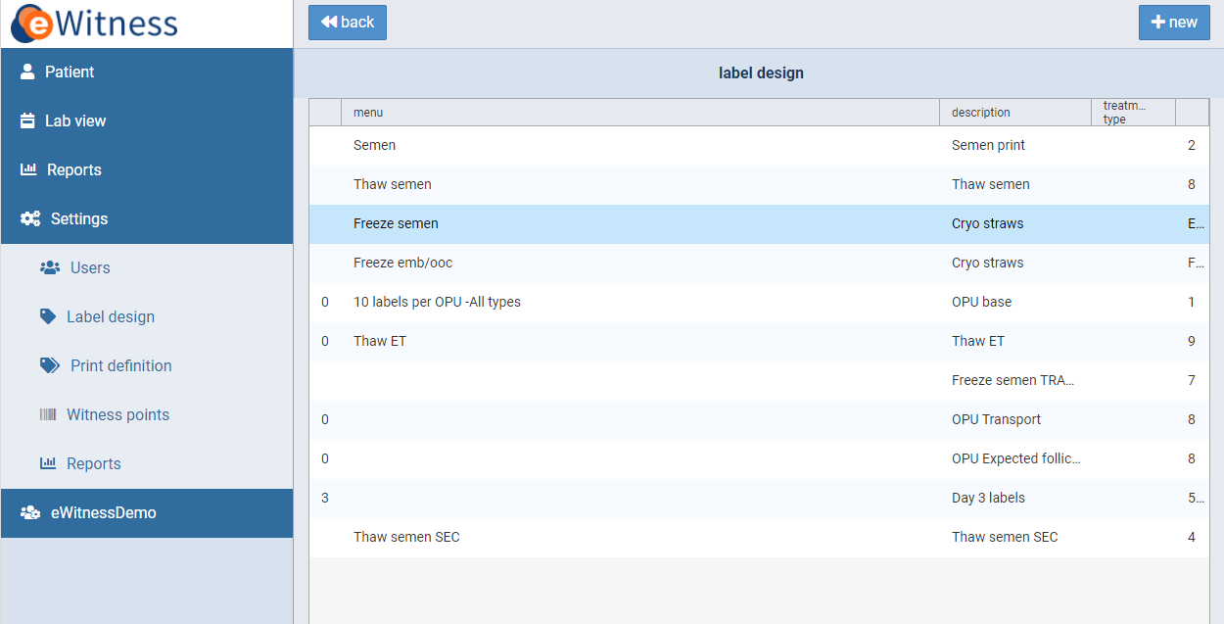Figure 4: Print-out definition overview

Once a print-out definition has been opened or created, a new screen will appear (fig. 5). Here, you can edit the definition settings. The screen consists of three sections: “print-out definition”, “linked to” and “template”. Use the “print-out definition” section to configure the item description, menu, entity, day and display order. The item description, menu, entity and day will be displayed on the overview screen. The display order can be used to alter the order of display on the overview screen.

The menu option will be used in the separate printer app. For the entity, a number of options are available:

**OPU** - All patients with a pick-up date will be selected. Typically used to label dishes and other “fresh” plastics.

**Semen** - All fresh semen-related labels. Patient selection is based on the production date. This can also be used for IUI-related labelling.

**Thaw semen** - Labels will be generated for patients that have the “use cryo semen” toggle active in the system.

**Thaw oocytes** - Labels for cryopreserved oocytes used. Based on the toggle “use cryo oocytes” in a witness cycle.

**Freeze semen** - Used to label straws in the cryo semen process.

**Freeze emb/ooc** - Used to label straws containing oocytes or embryos.

The field called “printer offset” can be used to give a specific print job a unique offset. Since all labels in eWitness are expected to be unique, you can use this when combining multiple labels in one witness step.

The “linked to” section is used to link the definition to a treatment type. Using quantity formula and exclusion, you can define the number of default labels to generate. eWitness uses unique labels so the number will also determine the number of unique barcodes to be generated. The field can hold a single number or use data from the eWitness system to determine the number of labels. For example, in the cryo ooc/emb process, the number of oocytes/embryos to be cryopreserved can be used to set the number of labels, or the volume of a semen production could change the number of labels needed. When the number needs to be based on a formula, eFertility can assist in the definition.

The “template” section links the definition to the label design. Use the 🔍 button to select the desired label. Once you’re finished, click the “save” button to save.

Finally, the “printer name” field is used to pre-select the right printer to produce the label. Any part of the printer name is used to limit the list of printers. This way, you do not run the risk of sending labels to the wrong printer.

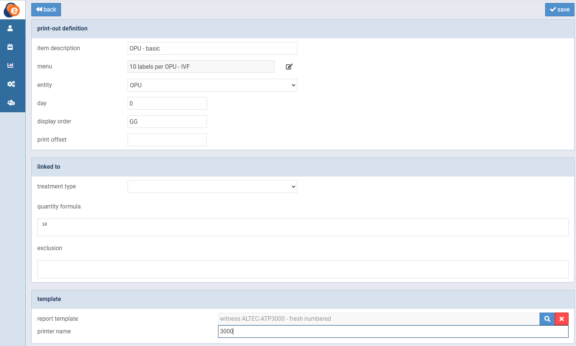Figure 5: Editing a print-out definition

When you use the print tool, these definitions are displayed and linked to the patients on the witness overview screen. From the tool, the witness cycles are linked to label definitions.

*Attention: Please note that printed labels contain sensitive patient data. Furthermore, the ink foil also contains the same data (in reverse). Please be aware that not only the labels, but also the ink foil is properly discarded after use.*

## Step 3: Define witness points

The last step in the eWitness set-up is defining the actual witness points. Using the process steps from your clinic, witness points will be triggered at the desired points in your workflow. These witness points have no direct relation to the label design and generation. All labels that belong to a patient are used during the witnessing process. Witness points are defined by adding signatures. The signature name is used to define all types of validation of process steps.

In the “Settings” menu, click on “Witness points”. This will give you an overview of your witness points (fig. 6). On this page, you can edit existing witness points or define new ones. Click on a column in the list of witness points to open it, or click the “+new” button to create a new one.

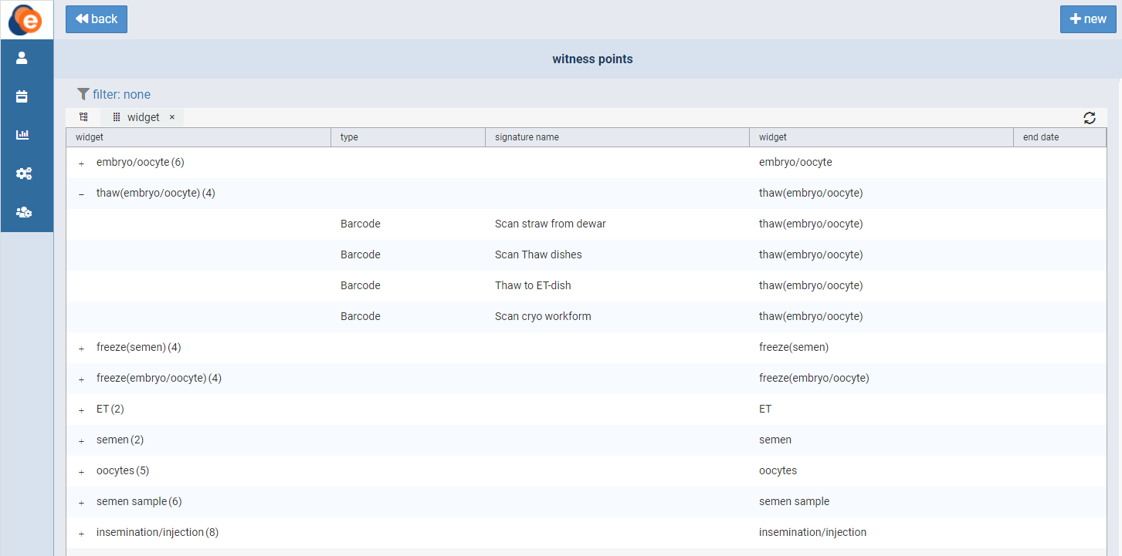Figure 6: Overview of witness points

Once a witness point has been opened or created, a new screen will appear (fig. 7). Here, you can edit the signature definition settings. The screen consists of one section: “define signature”.

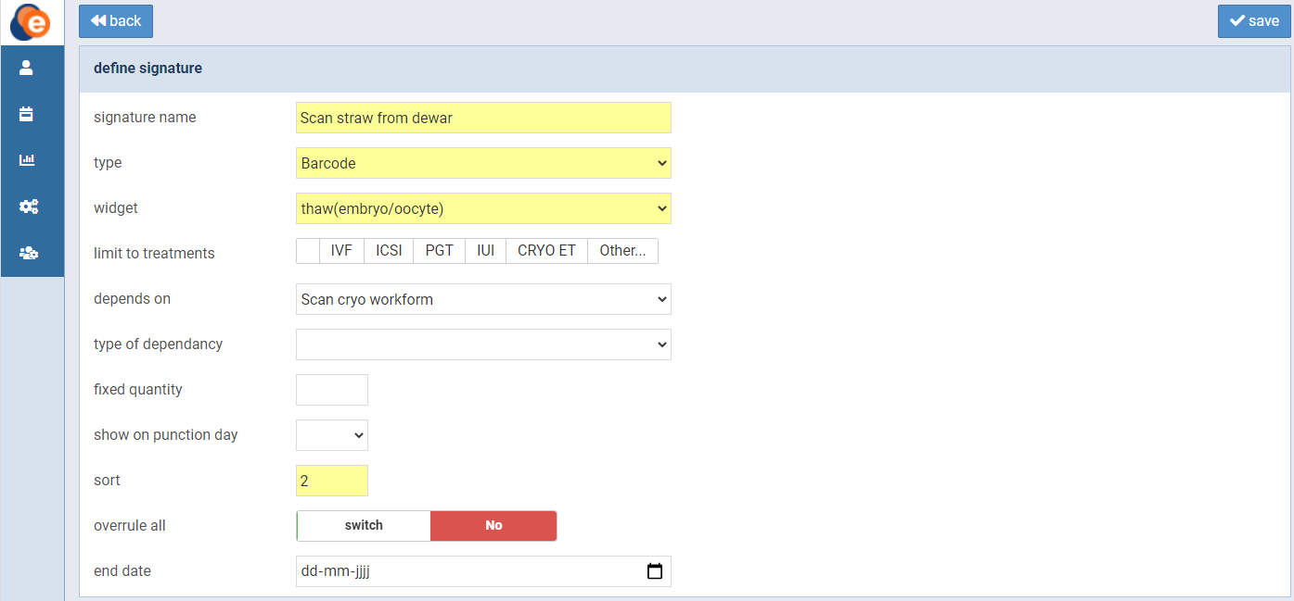Figure 7: Define signature

On the definition screen for the signature, you define the name, type, dependencies and all other characteristics for the witness point. When defining a witness point, you can use the elements listed in table 1. Once you’re finished, click the “save” button to save.

| **Witness point definition** | |
| --- | --- |
| Signature name | Name as displayed in the eWitness app. |
| Type | In order to display and use in the eWitness app, use “barcode” as the type. The type “patient” can be used in the back-office application to let a patient put in a signature using handwriting. |
| Widget | Select the widget for which you want to define the witness point. |
| Limit to treatments | Link the witness point to a type of treatment. Multiple treatments can be selected. |
| Depends on | This is used to chain witness points together. A witness point will not be available as long as the witness point it depends on is not validated (scanned). The “depends on” list is a list of the already defined signatures.  Best practice when setting dependencies is to start by defining all witness points/process steps. All new signatures will only be visible after a re-login, so setting dependencies will be easier this way. |
| Type of dependency | There are three types of dependencies. Each will have a different effect on the witnessing process.  The first, and default, type is “standard”.  A witness point will only be available after the parent witness point is completed. This is true for all types, but for this type, it is the only condition.  The second type is called “equal numbers”. It will check the number of scans performed during the previous witness point and will expect the same number of scans. Any deviation will result in a message about the difference.  The third type is called “exact match”. It does the same as the second type, but in addition, it will expect the exact unique labels scanned in the previous scan. |
| Fixed quantity | When you fill this field with a whole number, it will represent the number of labels to be witnessed as a fixed number. By default (empty), the number of scans is not pre-set. If you set a number here, the witnessing process will stop when the number is reached, and a warning will be shown if the number scanned does not match.  E.g. instead of stating “1 of N”, it will say “1 of 3”. After three scans, the witnessing process is considered complete. |
| Show on punction day | Select the punction day on which the witness point has to be used. |
| Sort | The order of display for the witness points. A sort order is mandatory in order to display the witness point. |
| Overrule all | The number of witness points per process is displayed in the eWitness app as a number. When all steps are witnessed, the number is replaced by an “eye” icon to represent a finished witnessing process.  There are situations where the definition of “finished” is flexible and does not contain the exact number of steps for each cycle. In these situations, you can define a witness point to “overrule all”. When this step is performed, the procedure is considered finished. |
| End date | Used to retire a witness point without losing historic validations. |

Table 1: Define signature elements

## User management

In the “Settings” menu, click on “Users”. This will give you an overview of the groups and users in eWitness (fig. 8). On this page, you can create and manage groups and users. Click on a group or user to open it, or click the “+new” button to create a new one (fig. 9).

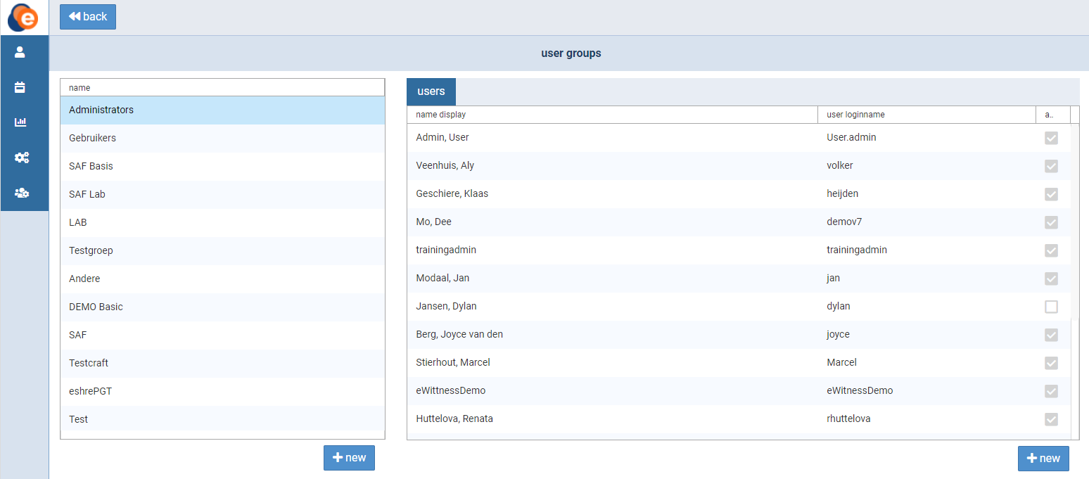Figure 8: User management

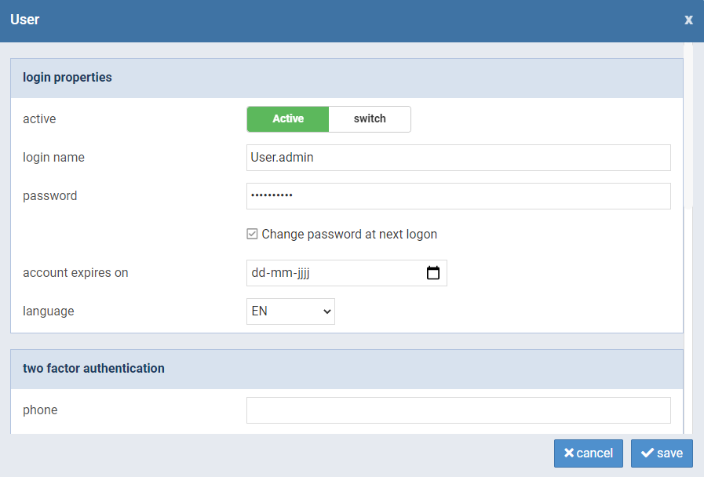Figure 9: Edit a user profile

## Report definitions

With eWitness, it is easy to produce detailed reports. In the “Settings” menu, click on “Reports”. This will give you an overview of your reports (fig. 10). On this page, you can edit existing reports or define new ones. Double-click on a report to open it, or click the “+new” button to create a new one.

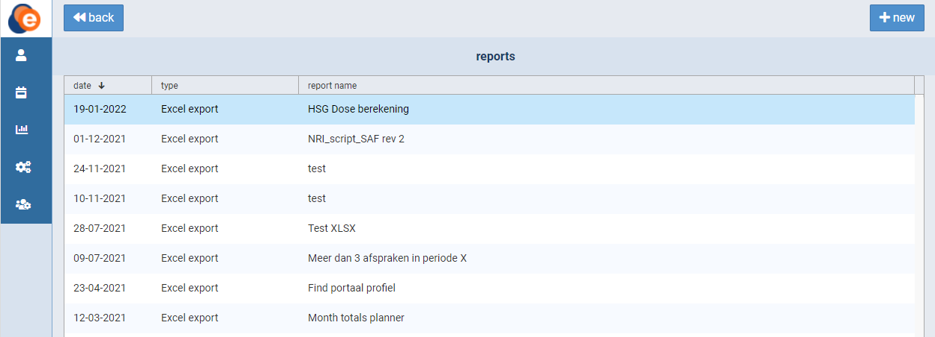Figure 10: Overview of reports

Once a report has been opened or created, a new screen will appear (fig. 11). Here, you can edit the report settings. The screen consists of two sections. Use the top section to configure the type, name, date and group of the report as well as the state (active/inactive). In the second section, the query for the report can be edited. If you don’t feel comfortable doing this yourself, feel free to contact eFertility for assistance. Once you’re finished, click the “save” button to save.

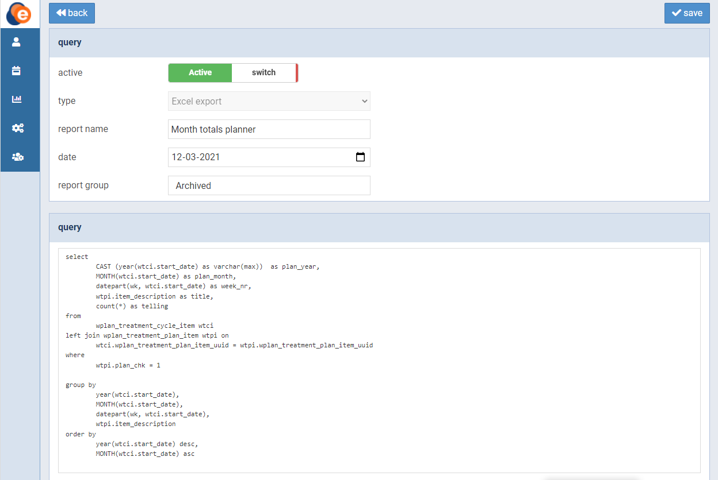Figure 11: Edit a report

# Putting it all together

Once labels are defined, print jobs are set and witness points are defined, the system is ready to be used. There is a separate manual available for the use of the eWitness front-end app.

The printer app needs to be installed on a machine that is connected to the label printers. There is also a separate installation manual for this printer app. This is used to produce the labels.

# Using the system to plan a witness cycle

## Finding or creating patients

To look up, edit or create patients, click on the “Patient” button in the menu. The patient overview screen will open (fig. 12). Here, you can find and edit existing patients. Your search can be based on the patient ID, date of birth, last name and/or donor code. If you want to add a new patient, click on the “+new” button.

Once you have found your desired patient, click the row to open it. You will enter the patient and couple screen (fig. 13). Here, you can edit the patient details, print ID cards, print reports or add a new couple. This screen also gives an overview of the couples linked to the patient. Open a couple by clicking on it, or click “+new couple” to add a new one.

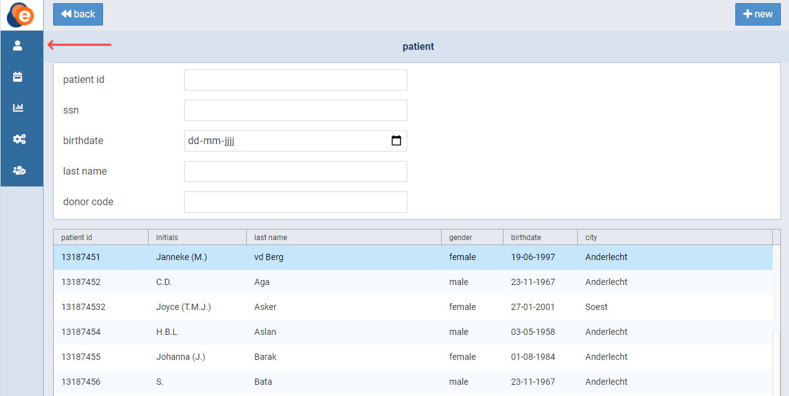Figure 12: Patient overview

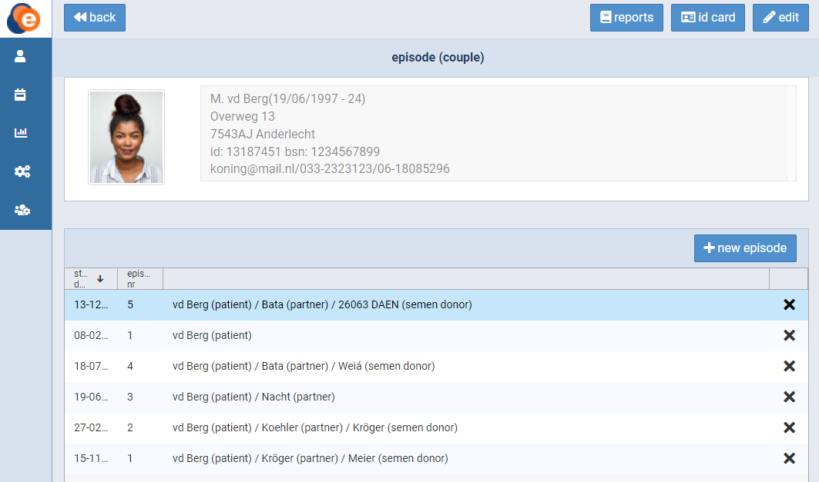Figure 13: Patient and couple screen

When editing patient data, you can add or change the patient's profile picture. To do so, click on the profile picture. A new screen will appear (fig. 14). Here, you can choose an existing picture or take one if your device has a camera.

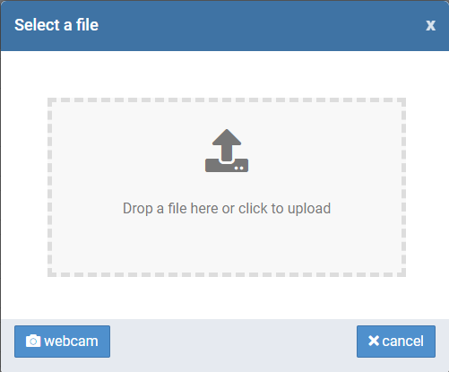

Figure 14: Add or change profile picture

## Linking patients together as a couple

To link patients, first create or find and open the female patient on which the couple will be based. Click on the “+new couple” button to create a new couple. A new screen will appear (fig 15). The second section (partner/donor) will be used to link patients together. Click on one of the two 🔗 link buttons to link the patient to either a semen source or an oocyte donor. In the case of a semen donor, use the partner/donor “switch” button to specify whether the semen source is a partner or a donor.

If you want to change or remove an already coupled donor, use the “link” button (which by now will be an “unlink” button).

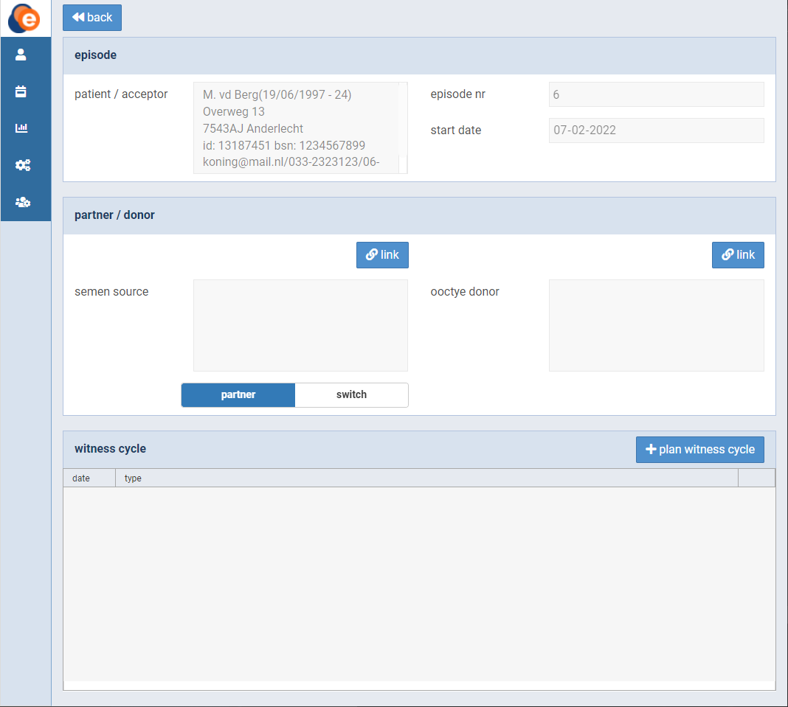 Figure 15: Create and/or edit couple

## Creating a witness cycle for a couple

Once you’ve created a couple as described in the previous chapter, a witness cycle can be created. To do so, click the “+plan witness cycle” button (fig. 15). A new screen will appear (fig. 16).

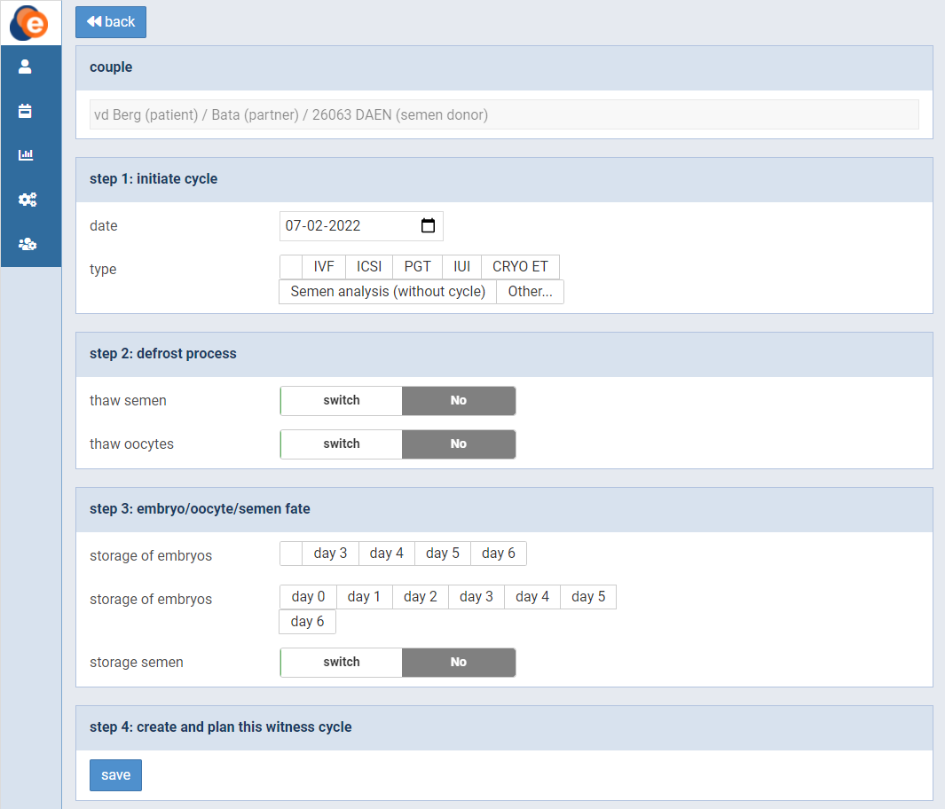Figure 16: Create and/or edit witness cycle

This screen consists of four steps. Step 1: Define the date and type of the cycle. Step 2: Choose to thaw semen or oocytes. Step 3: Define the embryo/oocyte/semen fate. Step 4: Save your set-up. The third step can be filled in at a later point in your workflow.

## Overview of witness cycles in the lab view

The day list (or lab view) screen gives you a complete overview of all the actions to be performed on a daily basis. To open it, click on the calendar icon in the menu (fig. 17). The screen consists of seven widgets: “semen”, “oocytes”, “insemination/injection”, “embryo/oocyte”, “et”, “freeze” and “thaw”. It is based on the witness cycles you’ve created as described in the previous paragraph. Select your desired date at the top of the screen.

Each widget provides information on witness cycles. It gives you the gender, patient name, patient date of birth, treatment type and number of signatures. If all the required signatures are set, a green eye symbol will appear. By clicking on a row, a witness cycle can be opened and edited.

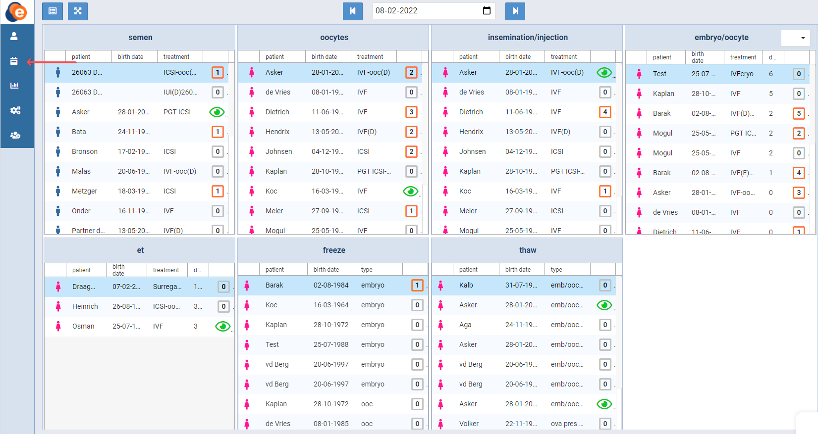Figure 17: Day list overview

Your workflow is designed through the set-up of witness points. To pass a witness point, a signature is required. The number in each row tells you how many signatures have already been set. The green eye symbol is shown when all the required signatures are in place. If you click on the number/green eye symbol, an overview of the required signatures will appear (fig. 18).

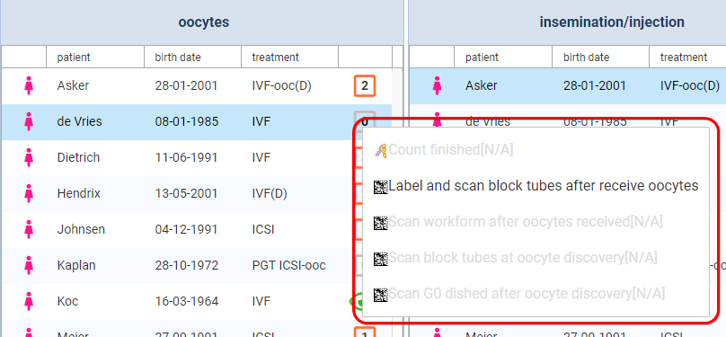Figure 18: Required signatures

Greyed out signatures can only be placed if the previous required ones are done. Whenever a signature is placed, the witness point will turn orange. Orange signatures can be removed by local administrators by clicking on them. In case witnessing cannot be done using the witness device, a signature can be placed using the back-office application. Click on the witness point to do so. A new screen will appear (fig. 19).

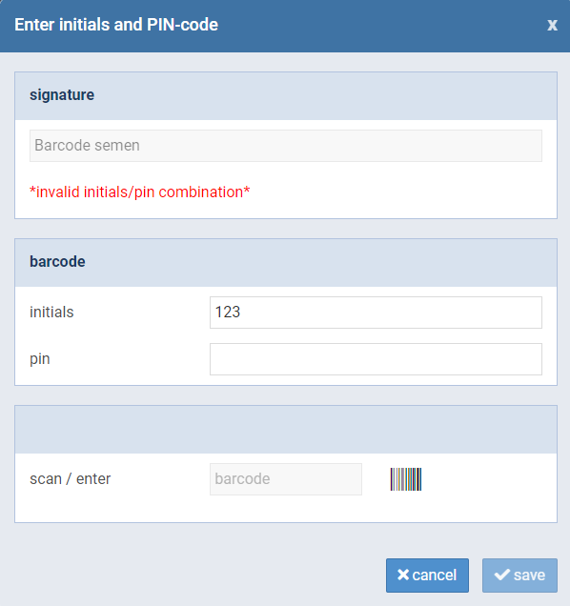

Figure 19: Enter signature manually

On this screen, you can place your signature by scanning a barcode or entering your initials and PIN code. Once you’re finished, click the “save” button to save.

## Tablet and desktop view

eWitness is designed to be used on either a mobile device or a desktop computer. The day list (or lab view) screen can be toggled between a view that is optimised for tablet screens and a view that suits a desktop computer with a large screen. In the top left corner of the screen, you’ll find two buttons (fig. 20). Use the left button to toggle between tablet and desktop view. The tablet view will give you the same details as the desktop view, but in a listed way. The right button will adjust the screen to fit your desktop.

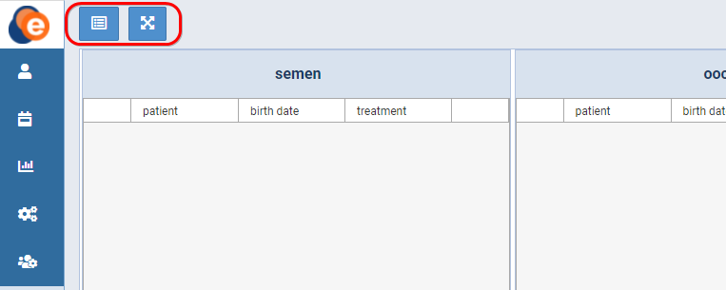Figure 20: Screen size buttons

## View and register misscans

In case of a misscan, a warning message will appear on the day list (or lab view) screen (fig. 21).

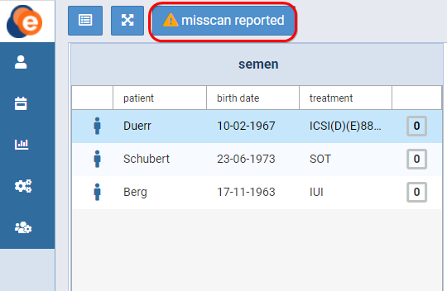

Figure 21: Misscan reported

By clicking on the “⚠misscan reported” button, you will get an overview of the misscan(s) (fig. 22).

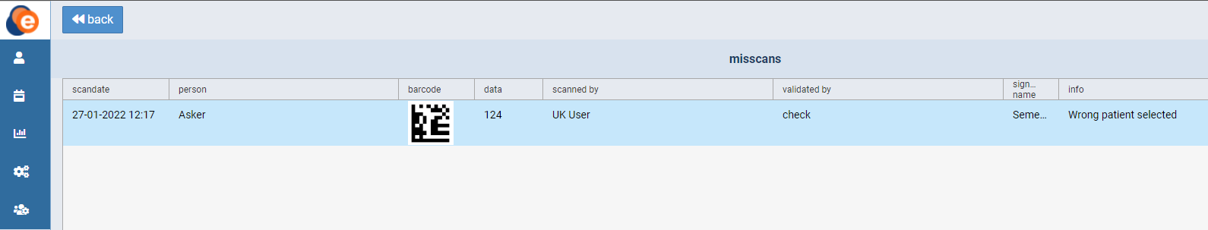 Figure 22: Overview of misscans

Click on the row to open the misscan. A new screen will appear (fig. 23).

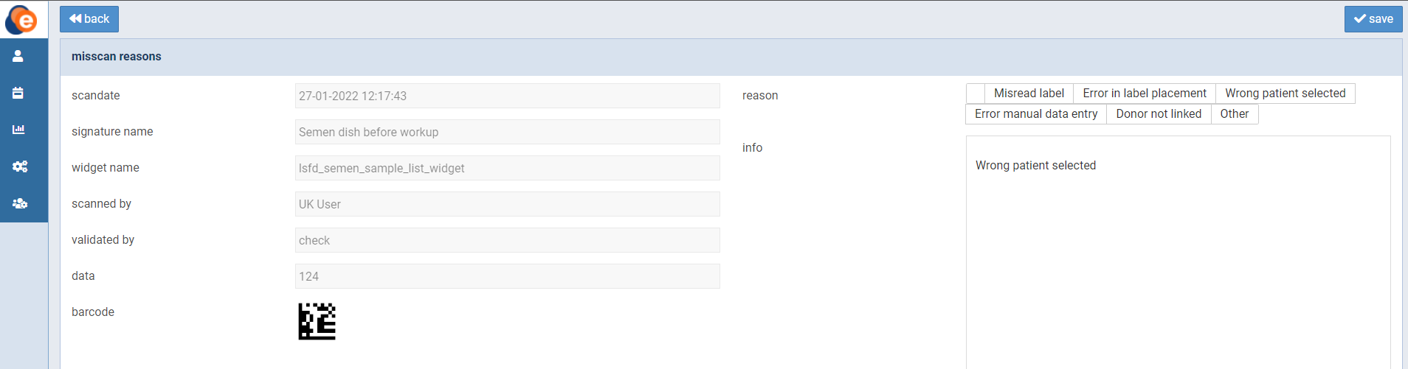Figure 23: Misscan detail screen

On this screen, you can see details about the misscan. You can also select a reason for the misscan, or manually enter additional information.