**User manual**



**Table of contents**

Introduction 3

Login/logout 3

Login using an ID card 4

Login using RFID/smart card 4

The overview screen 4

Task lists 6

The witness screen 6

Barcodes used 8

Scanning 8

Workflow management 8

Handling of misscans 9

Using external barcodes 9

App configuration 10

Material registration 11

Administration of materials 11

Adding a new material to the inventory 11

Linking a material/batch to a day 13

Linking a material/batch to a patient 14

eWitness RFID box (optional) 15

Positioning materials 15

Technical specifications and safety information for the HF RFID-shielded antenna 15

Graphical overview of the eWitness system 16

# Introduction

The eWitness app is at the centre of the witness solution by eFertility. The app is a native Android app that runs on the witness scanner provided by eFertility. Together with the scanner, the app controls the identification of patients enrolled in the witness process.

By configuring witness points into workflows, the app is used to follow process steps and to witness, log and validate all materials used along the way.

All steps that are witnessed are stored in the central eBase database for security, logging and easy access.

# Login/logout

The eWitness app is linked to a user account in the eBase database. Logging into the system is necessary to ensure that all steps are logged and linked to the appropriate user. The details of your login credentials are provided by the local administrator.

The login screen is also the place to see the current version of the eWitness app.

Because all witness points are registered using the credentials of the user logged into the app, it is essential to log out of the device after each use. This will ensure that the witness points are registered by the right user.

After logging in, the logout button is available from the menu under the cog icon in the top right corner of the screen.

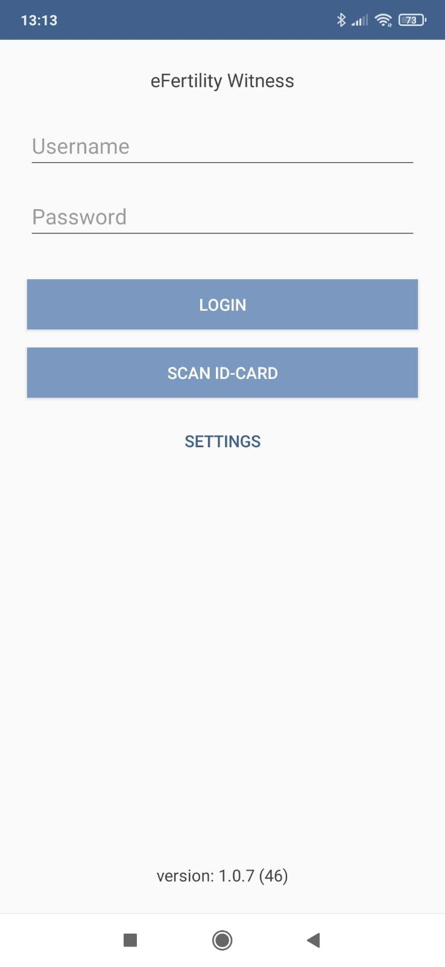

*Figure 1: Login screen*

## Login using an ID card

There is an option to use an employee card to log into the system. This card allows for a quick and easy login process. The card can either be printed using the card printer or stored in a personal phone.

## Login using RFID/smart card

In addition to the login option using a card generated by the system, there is also an option to use an existing smart card (employee card) with an RFID chip. In order to use this, users can link their own personal RFID card to the system. You do this by first logging into the system and navigating to the setting. There, you will get an option to link an RFID card to your personal login.

# The overview screen

After a successful login, the app presents the overview screen. On this screen, you see the process groups defined in the app. There groups represent tasks or “workstations” in the lab. For each task, a list of patients is shown. This list represents all patients that are witnessed on a specific date.

The tasks are:

|  |  |
| --- | --- |
| Semen | All male patients or semen donors with either a semen sample used during a procedure or a separate semen sample to be analysed. |
| Oocytes | Patient with a pick-up. Used for oocyte retrieval and count. |
| Insemination/injection | The process of insemination or injection of oocytes. This is where semen and oocytes come together. |
| Oocyte/embryo | Monitoring of the development and fate of oocytes and embryos. |
| ET | Transfer of embryos back into the patient. |
| Freeze | Cryopreservation of either male of female material (semen, oocytes, embryos, etc.). |
| Thaw | Monitoring and logging of transfers out of the cryobank. |

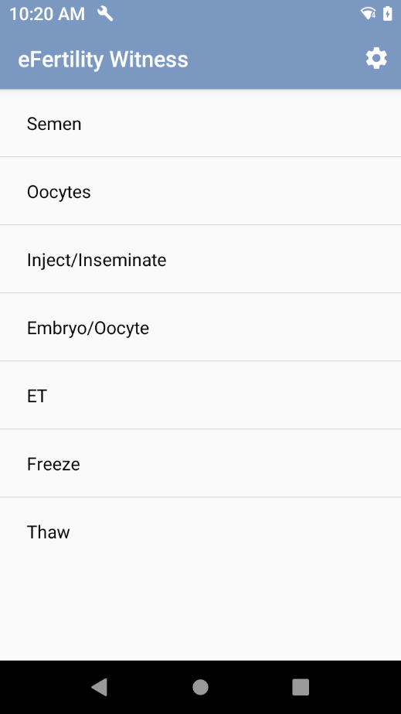

*Figure 2: Overview of task groups*

# Task lists

When you select one of the main tasks, a list of patients is presented. This list is grouped per day and per task. The day is set to the current day by default, but can be changed using the arrow icons next to the date. Each main task can have its own workflow consisting of a number of steps or “witness points''. In the list, the number of completed steps are displayed. When all steps are complete, the process number is replaced by an eye icon. When you select a patient from the list, the witness screen is presented. On this screen, the process steps are displayed and can be selected.

*Figure 3: Oocyte task list with witness progress*

# The witness screen

On the witness screen, the details are presented to start and perform the witness process steps. The screen has a number of information elements and functions. From this screen, you can:

* See information about the patient, partner and type of task
* Select witness steps and see completed steps
* Scan barcodes/RFID tags and see the number of unique scans performed
* Follow the pre-defined workflow that is presented
* Register an external barcode
* Handle misscans
* Enter a barcode manually as a fallback mechanism
* Finish and commit all registered scans

These functions are represented in the screenshots below with the appropriate letter.

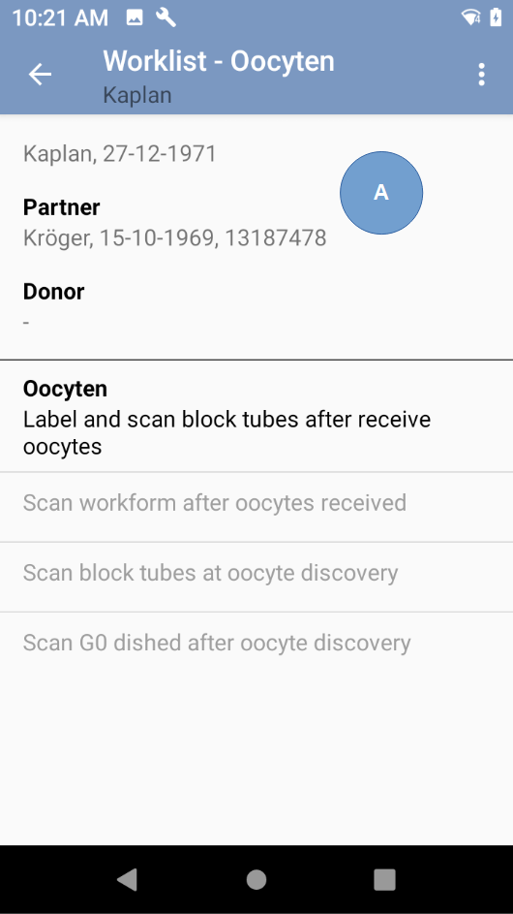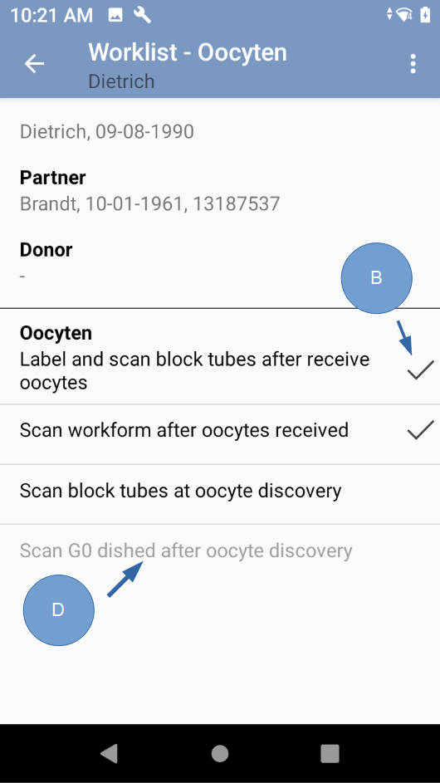

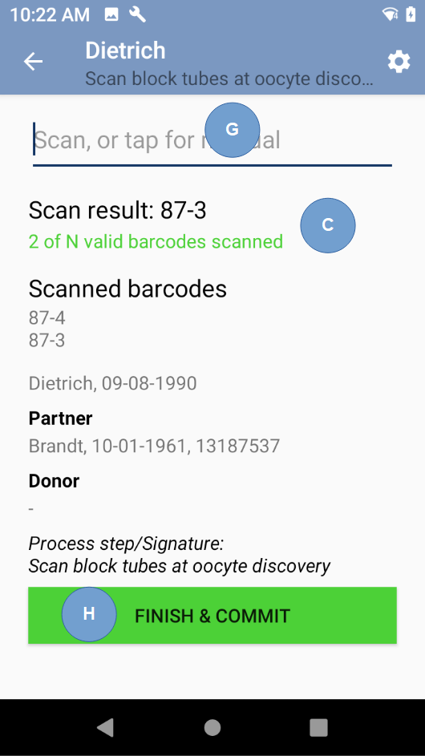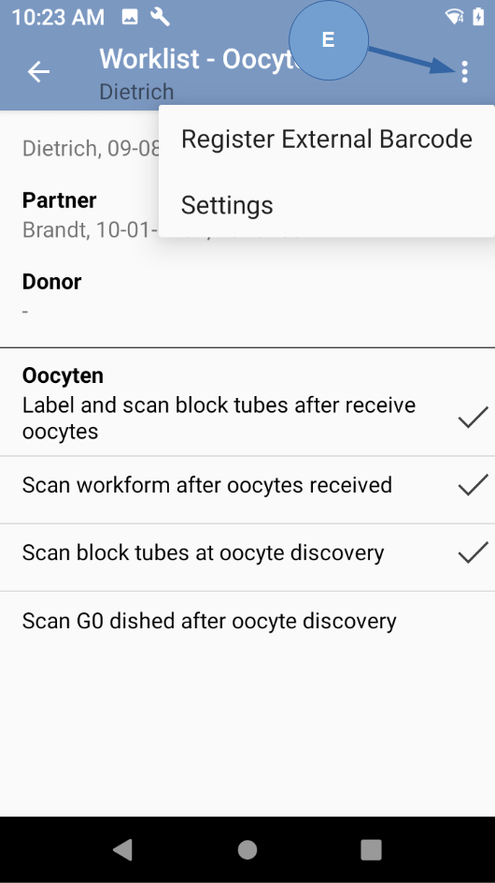

*Figures 4, 5, 6 and 7: The scan screen*

## Barcodes used

eWitness always uses unique barcodes per label. This is independent of the label layout or the barcode type. eWitness uses 2D barcodes (DataMatrix) for all fresh materials and 1D barcodes (code128) for cryo labels. The 2D barcodes have a higher density and take up less space on a label. Although very reliable, small and easy to scan, a 2D barcode is less suited for a small, rounded surface such as a cryo straw. Therefore, eWitness uses 1D linear barcodes for this process. The layout of labels and the selection of barcode types is configured in the back office. All labels, 2D or 1D, are interchangeable.

## Scanning

The scan process checks barcodes or RFID tags to validate that they belong in the selected process. A valid scan is a scan of a barcode or tag of any of the persons associated in the process. This can be the patient, the partner or the donor. Each scan process consists of a series of scans of unique barcodes/tags. The barcodes/tags from eWitness are unique by default. Each label has a unique code that can only be scanned once in a witness step.

After all barcodes/tags are scanned during a scan process, they can be submitted and are sent to the server. This is done by pressing “Finish & Commit” at the bottom of the scan screen.

# Workflow management

During the configuration of the system, witness points are defined. Each witness point can be related to another by setting the dependency. This enables eWitness to guide the user through a customer-specific workflow. A scan that depends on another is not available for selection until the previous witness point is completed. As a user, you simply select the first available step in the list of process steps. After a successful completion, the next step in line is enabled automatically.

## Handling of misscans

With each scan, the system validates and logs the labels. If there are no errors, this process can continue. If the wrong barcode/tag is scanned, a number of things happen. First, the misscan is sent directly to the server. This process cannot be interrupted and is done automatically. This ensures that a misscan is always reported on the server. The second action is that the system asks for confirmation by a second user. This second user has to use his/her login credentials to confirm their visual witness of the error situation. By adding this mandatory step, the system can ensure that a misscan is given the proper attention. On the server, the original scan, the misscan and both users involved are logged and reported.

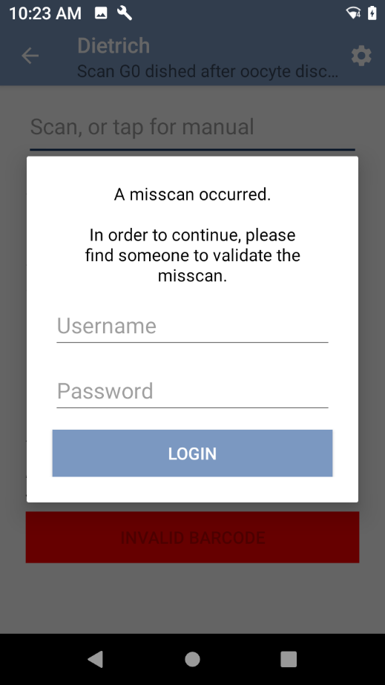

*Figure 8: Misscan validation*

## Using external barcodes

By default, all witness cycles are labelled using the eWitness system. The labels are generated from the back office and contain the unique barcodes from eWitness. In situations where the cycle is not initiated from eWitness, there is also a possibility to register an external barcode. Examples include labels that come in with cryo transport, existing barcode systems like an EmbryoScope or existing labels stored in cryo from proprietary systems.

You can register an external label directly from the witness screen by clicking on the context icon (…) in the top right corner. This will bring up the external barcode dialogue.

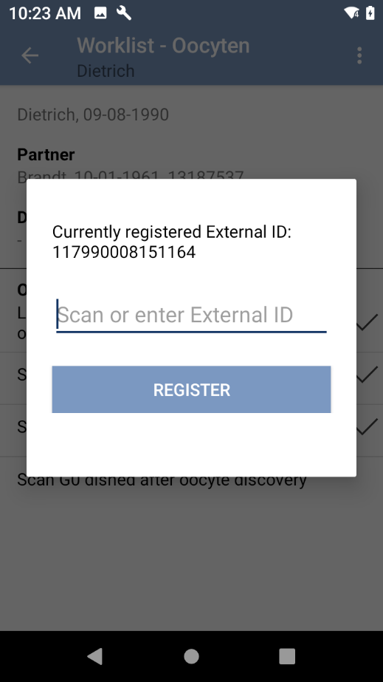

If there is already an external barcode, the code is displayed. From this screen, you can use the scanner to incorporate the external barcode into the system. For safety reasons, the external barcode cannot overlap with internal barcodes. A second limitation of using an external barcode is that these are not unique per label. The added security of knowing that you have scanned all labels once cannot be guaranteed. Using an external barcode is therefore useful, but is not standard practice. You can have multiple barcodes registered for a single patient, but the system cannot check whether the external barcode is unique.

## App configuration

On the main login screen, there is an option to configure the app. On the configuration screen, there are a number of settings to enable the app to interact with the central database. Once the app is configured correctly, these settings will not change. The options on this screen are:

|  |  |
| --- | --- |
| Server IP/DNS | The “address” of the eWitness server. |
| API key | The application connection password. Independent of the user password. |
| Scan mode | Uses an internal scanner by default. The setting is used to allow for a separate Bluetooth, serial or USB scanner. |
| Login timeout | Maximum idle time before the app logs out. |

# Material registration

The eWitness app can be used for the witness process as well as for batch tracking or material registration. There is an option to include new inventory, an option to link a batch to a specific date and an option to link a batch to a specific workflow/patient.

## Administration of materials

With the material registration option enabled, you can add batch tracking to the eWitness system. By doing so, you will be able to register materials using the barcode scanning ability of the system. As long as the barcode is unique, you can use a wide range of barcodes to include in your inventory. These include external barcoding systems such as GS1-EAN13, GS1-EAN8 and UPC or other coding systems found on most consumables. If needed, you can also use a locally generated barcoding system generated internally by the eWitness system.

## Adding a new material to the inventory

From the main screen, a new batch of materials can be added to the inventory. This is a mandatory step before using the list of batches to link them to a specific day or patient. The inventory list can be viewed from the main screen.

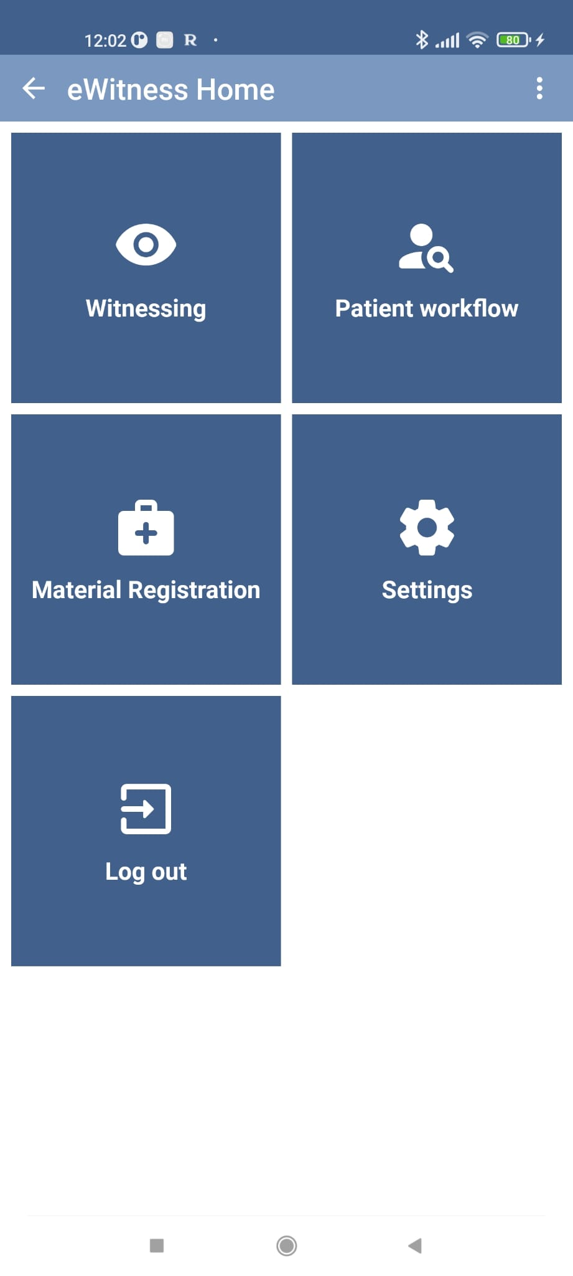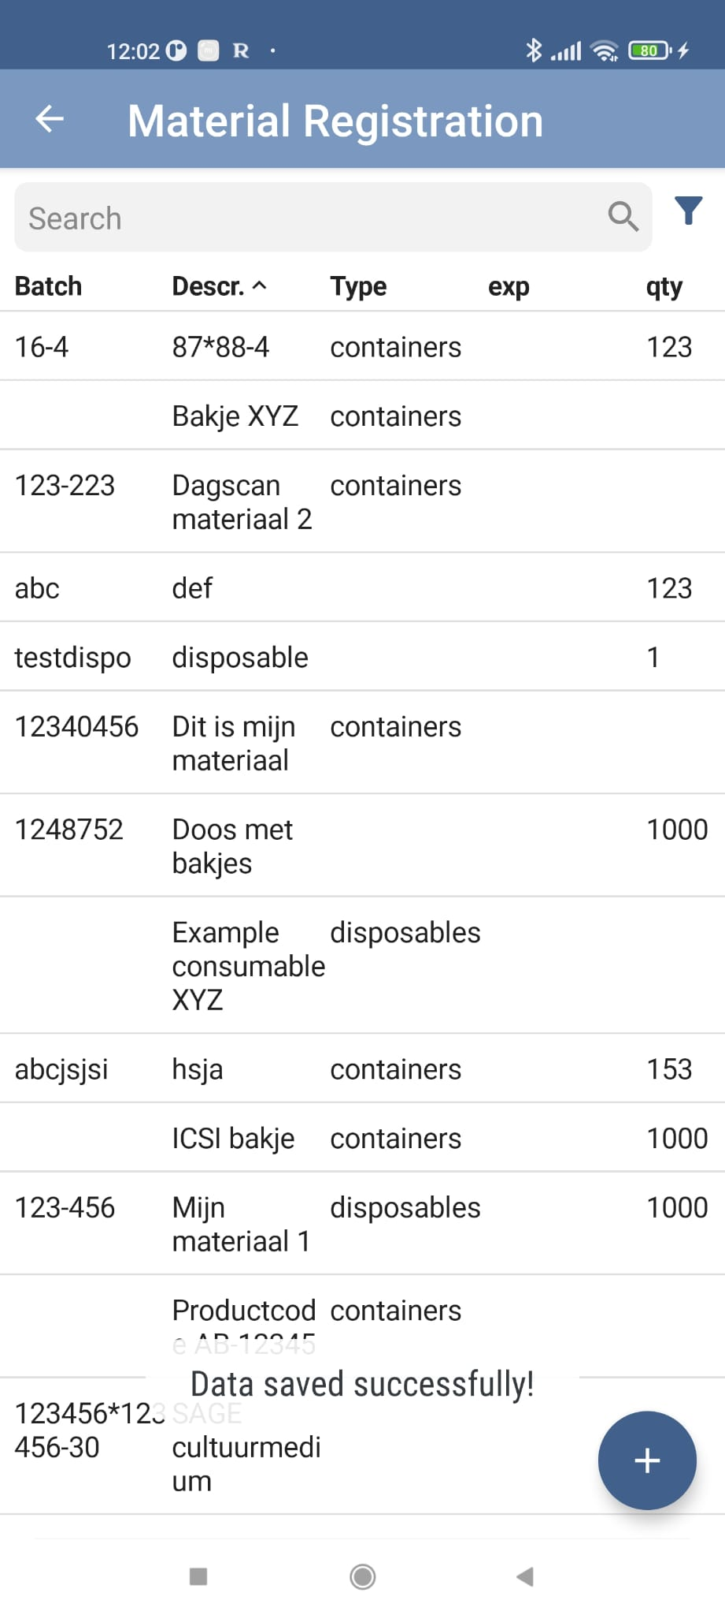

Adding a new material is done by pressing the “+” in the bottom right corner.

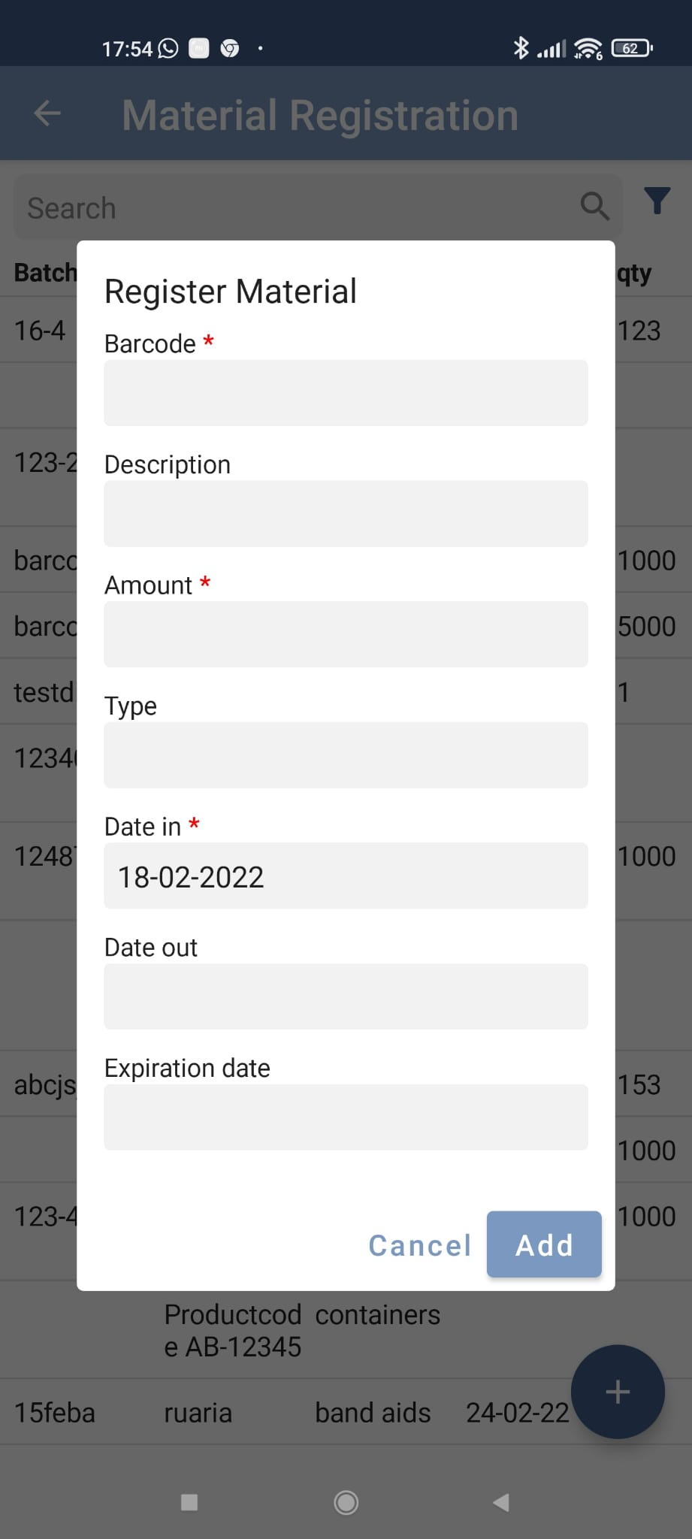

To register the barcode, you can scan it into the system.

### 

## Linking a material/batch to a day

The eWitness batch tracking has two modes of operation. You can register the use of a material for a specific day or you can link it to a specific process for a patient. By linking it to a day, you can trace what materials were in use during a specific day. All patient materials witnessed during that day are indirectly linked to that “day scan”. This is less specific than linking them to a specific patient. This option can be used for batch tracking that is not variable per patient. The advantage of this option is that it is less time-consuming. Day materials, as they are called in the eWitness app, are registered from the Witness Tasks menu that is set per day.

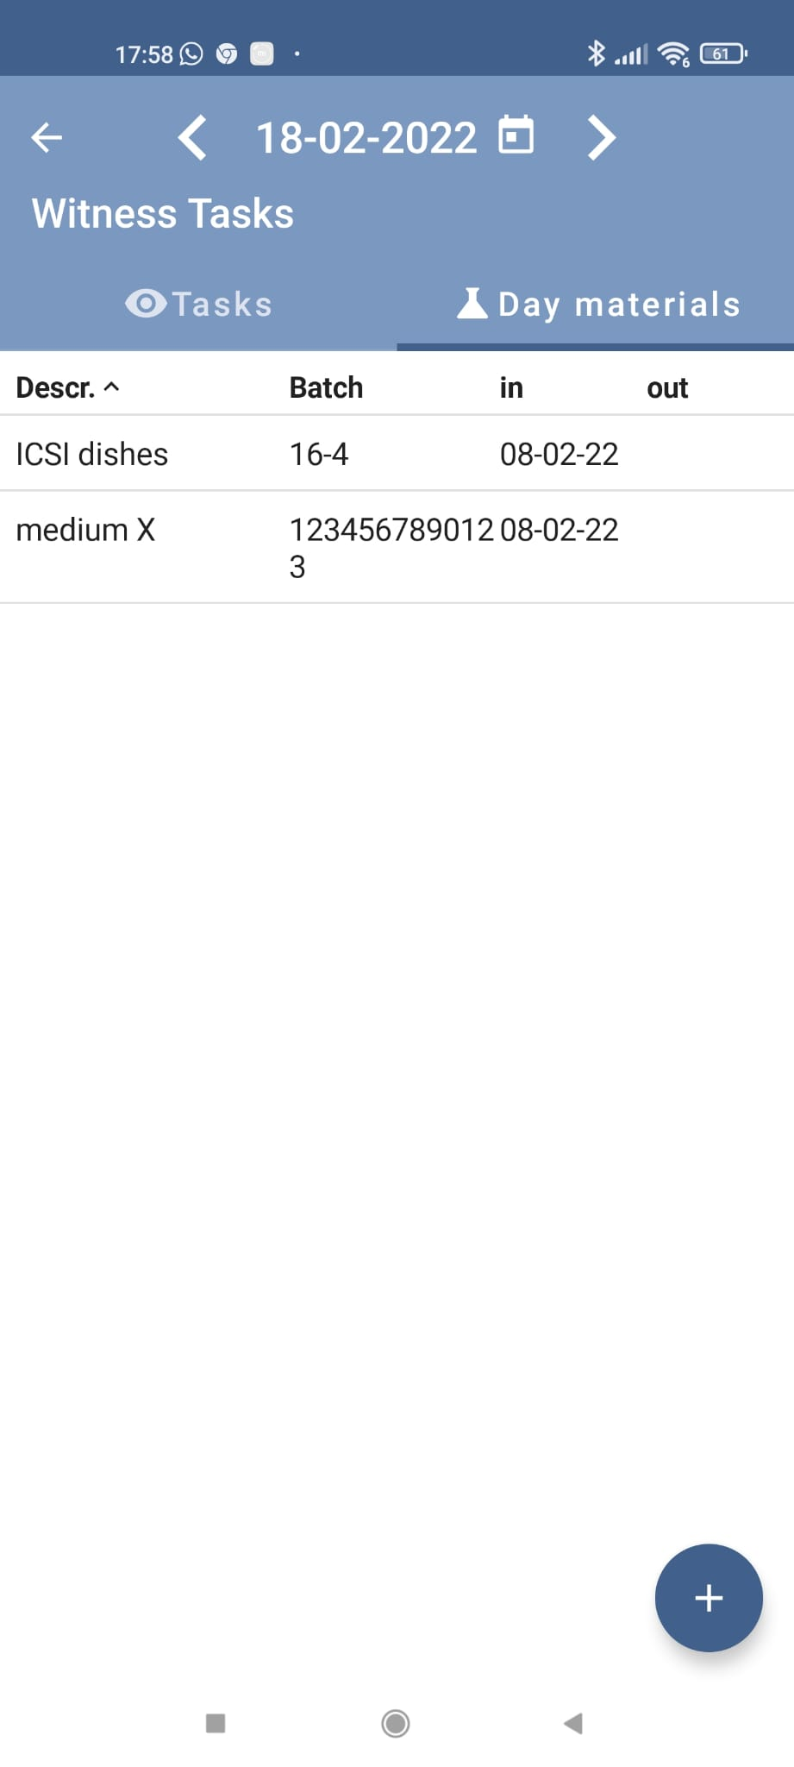

To register a known batch, you press the “+” in the bottom right corner.

### 

## Linking a material/batch to a patient

For material tracking per patient witness process, you have the option to link a material to a specific patient on any given day. This is done by selecting the “Material” tab after selecting a patient from the witness task list.

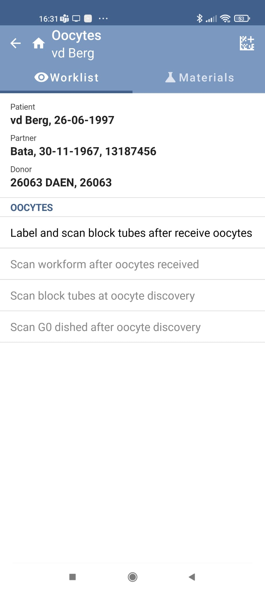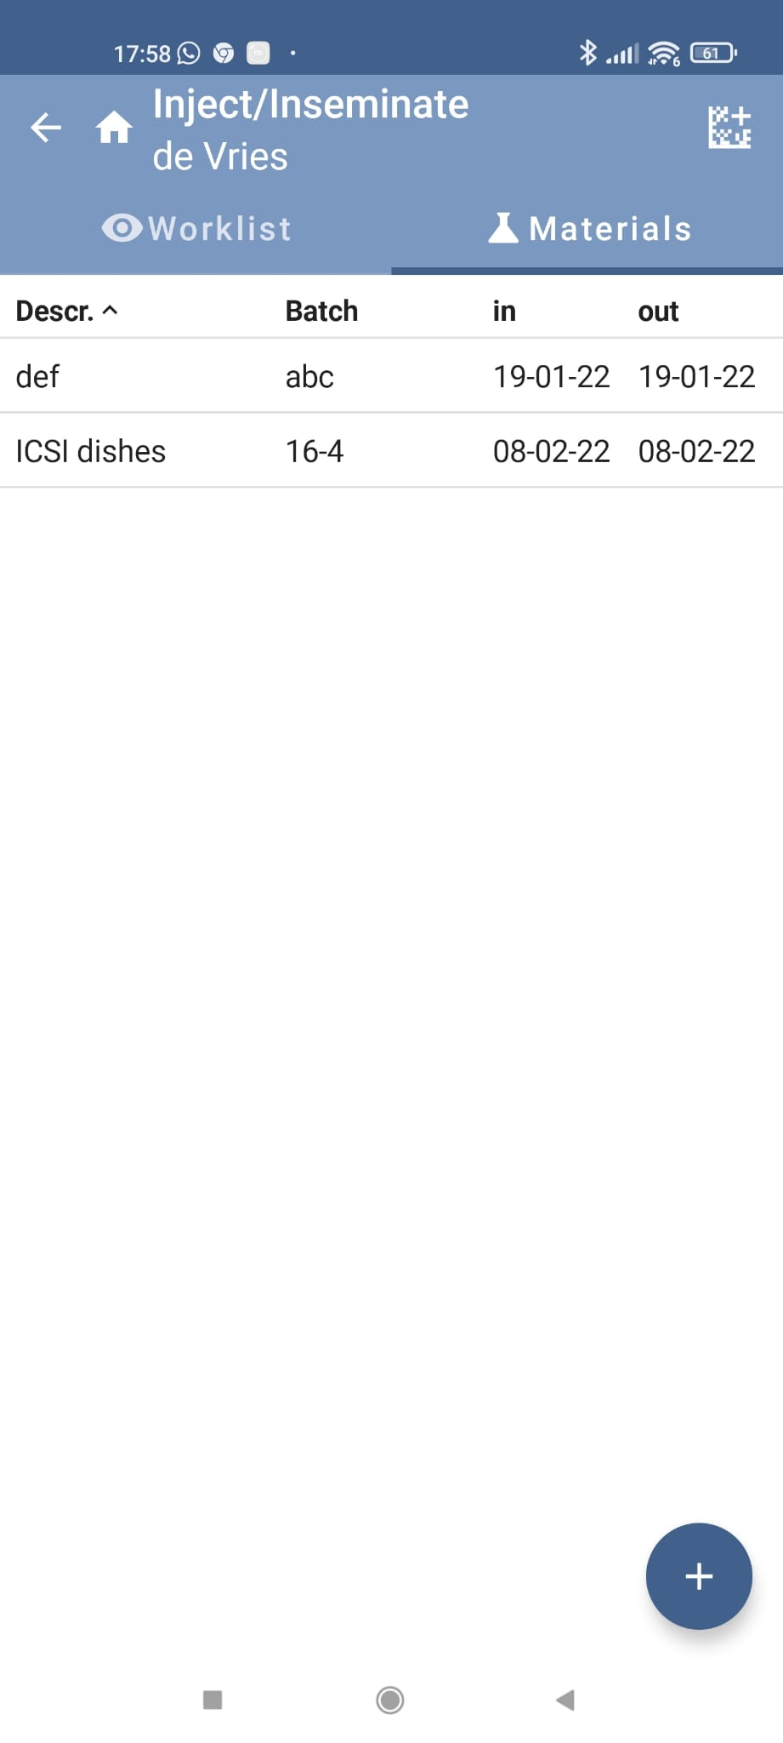

# eWitness RFID box (optional)

The optional eWitness RFID box allows you to automatically scan multiple gametes at the same time. You can keep your hands free when needed. It is not necessary to replace flow cabinets as the eWitness RFID boxes are easy to add to your existing environment.

## Positioning materials

To take advantage of the possibility of validating multiple gametes at once, RFID boxes can be used. To do so, position the tagged material right in front of the installed box. Make sure the material is positioned within 1 cm of the white side of the box and does not protrude left and/or right:

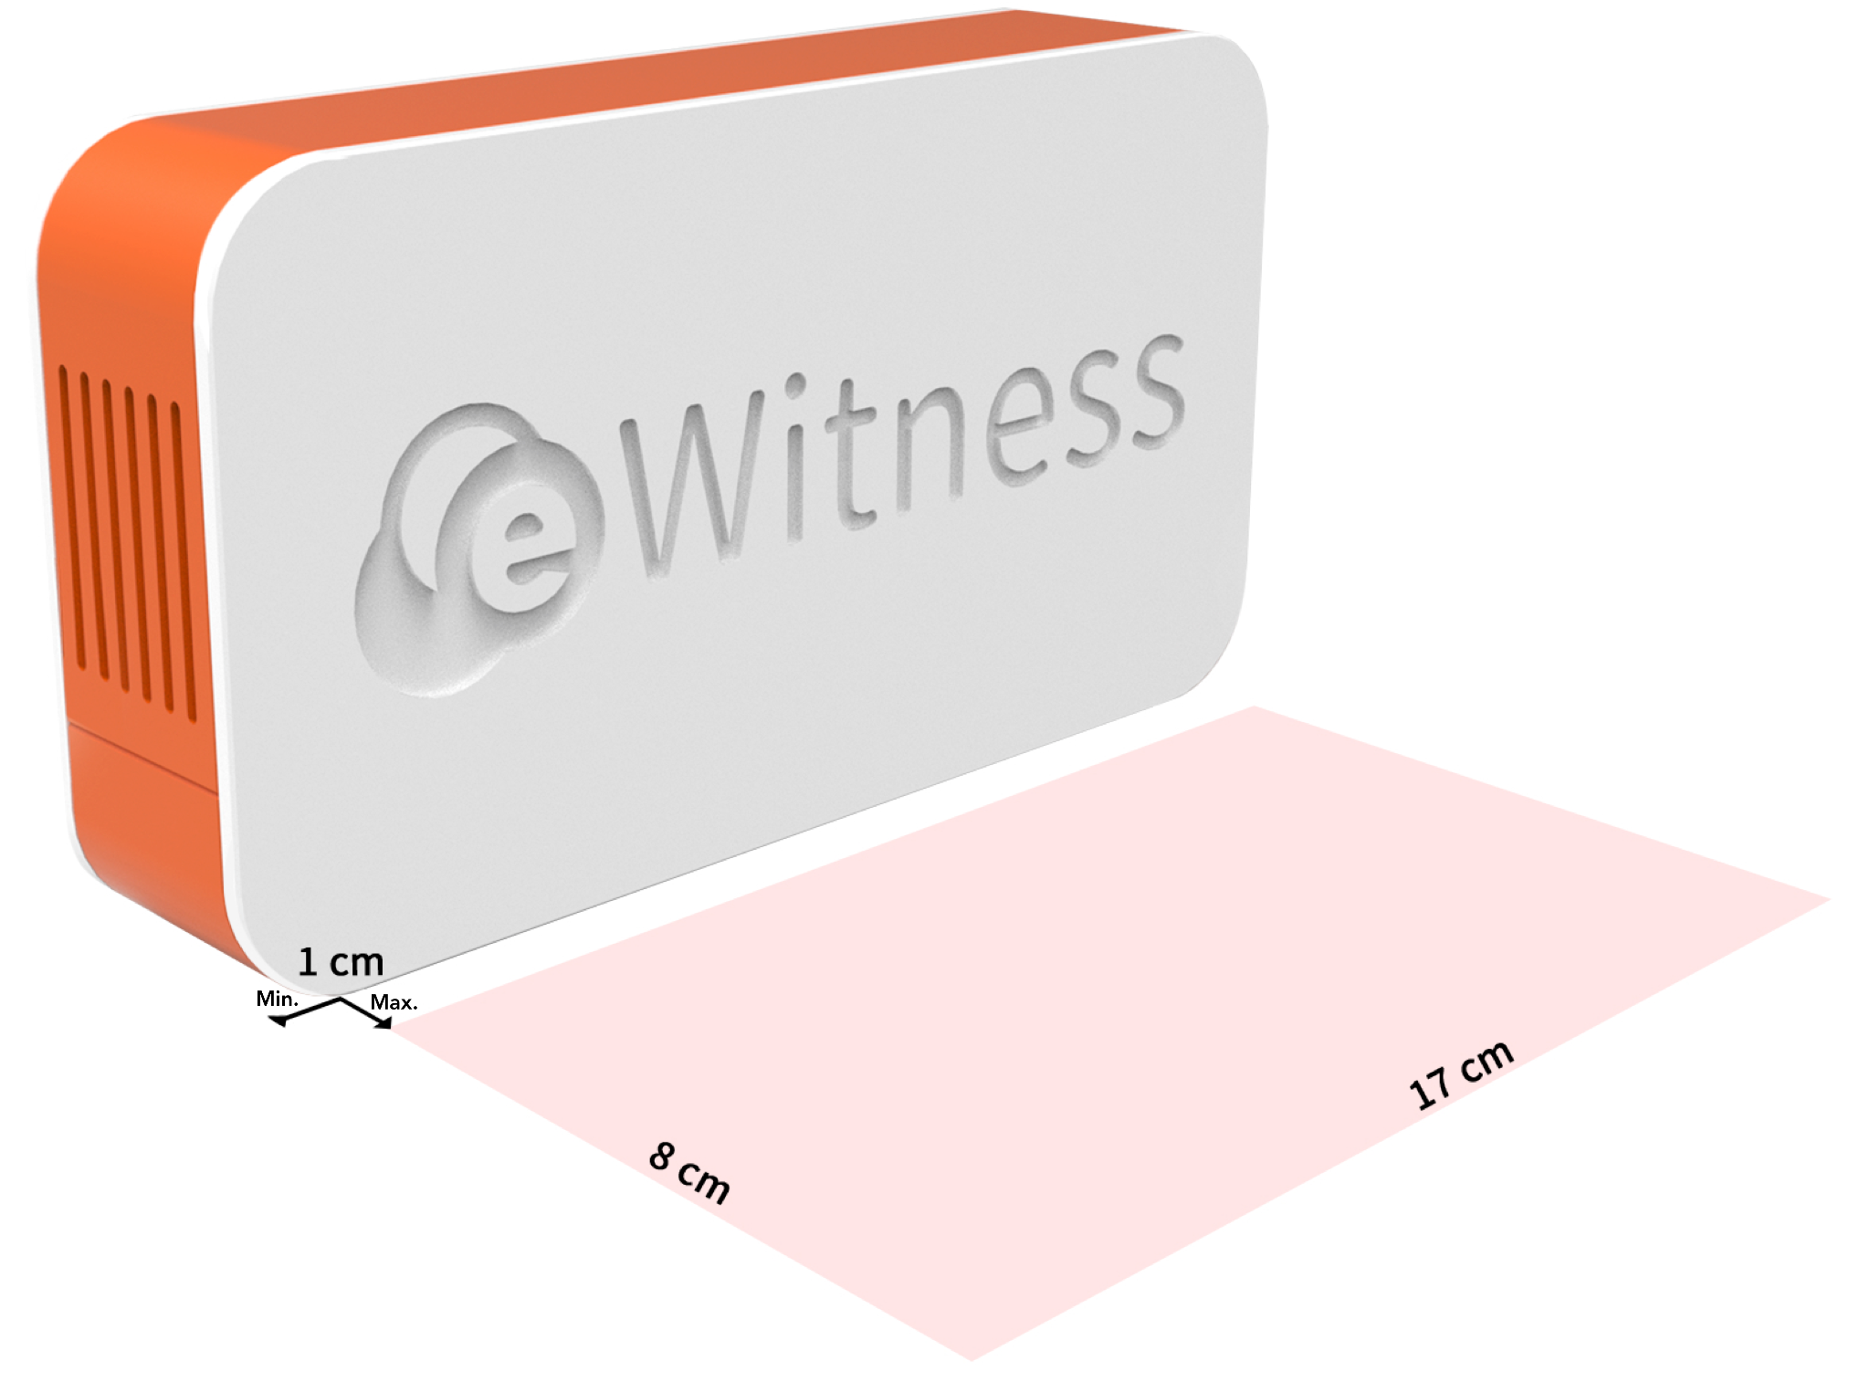

Depending on the size of the racks in use in your laboratory, more than one RFID box can be installed per workstation.

## Technical specifications and safety information for the HF RFID-shielded antenna

Frequency band: 13.553 - 13.567 MHz

Maximum radio frequency power: 4 W

* Modification of the HF RFID-shielded antenna without permission may result in fire, electric shock or personal injury.
* Installation and maintenance of the HF RFID-shielded antenna may only be performed by a person authorised by eFertility.
* The use and installation of the HF RFID-shielded antenna must comply with national legal requirements and local electrical regulations.
* Never cover the vent holes on the HF RFID-shielded antenna in part or in whole as this may cause the HF RFID-shielded antenna to overheat.

## Graphical overview of the eWitness system

***passive RFID tag***



1: RFID box

2: RFID reader

9: Power adapter

8: USB adapter

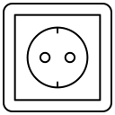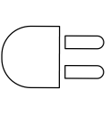

6: Tablet

5: USB C extension cable

4: Splitter USB C male to USB A female & USB C female

3: USB A to USB A cable

7: USB C to USB A cable

|  |  |  |  |
| --- | --- | --- | --- |
|  |  |  |  |
| 1: RFID box | 2: RFID reader | 3: USB A to USB A cable | 4: Splitter USB C male to USB A female & USB C female |

|  |  |  |  |
| --- | --- | --- | --- |
|  |  |  |  |
| 5: USB C extension cable | 6: Tablet | 7: USB C to USB A cable | 8: USB adapter |